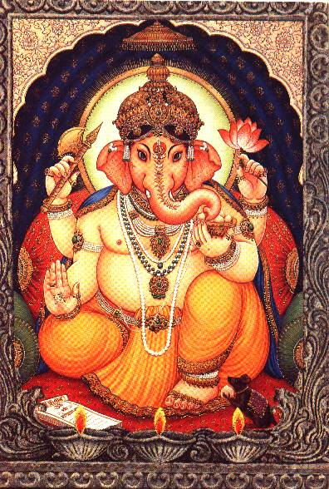

HOROSCOPE OF DAMAYANTI

Date of Birth → 25.04.1978 (Tuesday) Time of Birth → 12:20 pm

Place of Birth → Bhopal Ayanamsa → 23:33:16

Sunrise/Sunset → 5:35/18:20 (LMT) Sid. Time → 2:11:24

Birth Star → Anuradha 2 Pada Thithi → (Krishna) Thritiya

Vimsottari Dasas : Sani Dasa remaining at birth : 10 YRS. 5 MONTHS 2 DAYS

BUD
KET SUR SUK GUR

KUJ LAG

RASI

SAN

CHA RAH
SAN
RAH

SUK SUR

NAVAMSA

BUD

GUR LAG KUJ CHA
KET

